Christ the King Ambo Archive
  - Design history correspondence drawings and financial records
Christ the King and Marquette Historical Archives • 22 September 2026
The sanctuary ambo was developed through collaboration among Ed Grewe, Doug Bracken of Wiemann Metalcraft, Midwest Marble, and parish representatives. The 2022 parish communication describes it as Ed Grewe’s gift in memory of his wife, Yvonne. Its materials and carved details were intended to connect the new furnishing with the existing sanctuary and communion rail. [S1, S2]
This file brings the design sequence, parish correspondence, quotations, invoice, and photographs together. The financial record establishes a $22,000 designated gift and a $29,071 invoice after a $3,000 reduction. Those amounts document funding and billing; the invoice does not establish payment. [S3, S4]
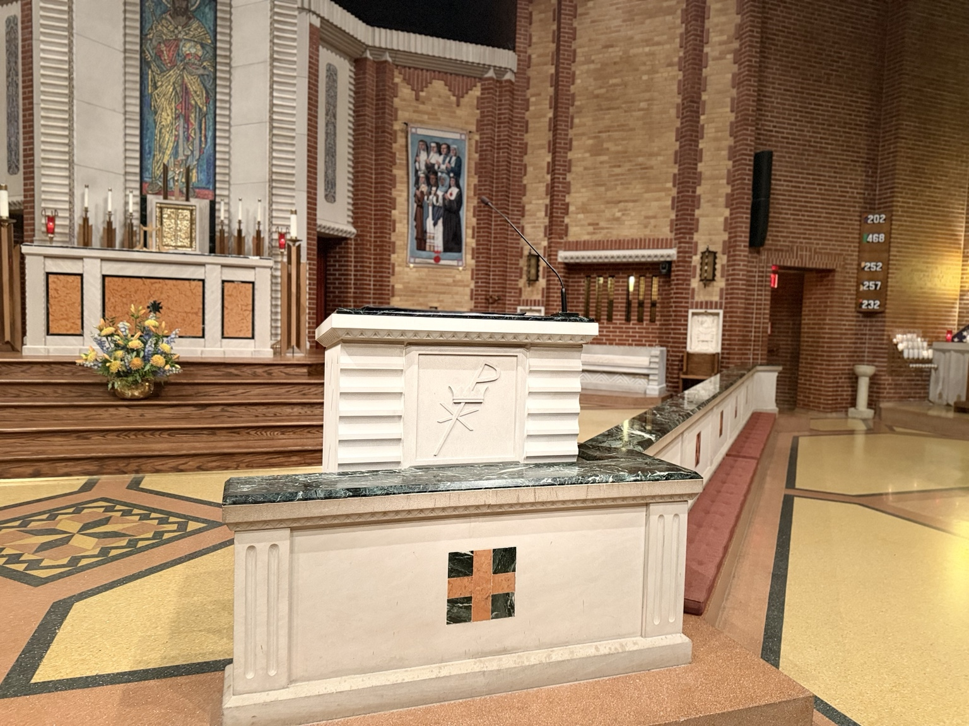
Figure 1. The ambo within the sanctuary and communion rail. Photograph supplied by Chris Davenport, IMG_8732(1).jpeg. Capture date not established.

Design intent and sources
The design correspondence places the ambo within the church’s existing architectural vocabulary. In the archived Ambo correspondence document, Chris Davenport asked for limestone and simple, symmetrical lines that would assimilate the furnishing into the sanctuary without distracting from the Eucharist. Doug Bracken’s early description proposed a recessed relic, a scalloped stone surround, a green marble top matching the rail, and diamond and linear details drawn from church architecture. The proposed height and plinth were design concepts, not measurements of the installed object. [S2]
On December 23, 2021, Davenport specifically asked to see recessed side diamonds similar to the ceiling and asked about green inlay. Bracken’s accompanying description referred to a seventh diamond and edge trim for visual assistance on the platform. These exchanges document alternatives under consideration. They should not be read as a description of every feature ultimately built. [S5]
The October 2022 parish write-up explains the intended relationships more directly. It connects the diamonds to the terrazzo floor and the white scalloped points above the stained glass. It connects the patterned limestone around the centerpiece to the surround of the Christ the King mosaic. It identifies the carved centerpiece as the parish’s original logo, also present near the church’s wooden entrance doors. Fr. Elkin González reviewed this wording on October 19. [S1]
That write-up also records a recollection attributed to former pastor Fr. Tam Nguyen: the Mary, Queen of Peace Chapel was designed as a continuation of the sanctuary. This is a contemporary parish explanation of design intent. It does not independently establish authorship or dates for the older architectural elements. No attribution to Bruce Goff is established by the ambo correspondence cited here. [S1]

People and responsibilities
Person or firm | Documented role
Ed Grewe | Donor and participant in design review; the archive preserves a sketch under his name.
Doug Bracken | Design coordination and revisions; email signature identifies him with Wiemann Metalcraft.
Midwest Marble and Steve Ferguson | Pricing, stonework coordination, installation, and invoice. Ferguson signs the quotations.
Ranier Devido Stone Co. | Named on the May 23, 2022 production drawing sheets for Midwest Marble.
Parish representatives | Chris Davenport coordinated project details; Fr. Elkin González reviewed design and communication; John Sommer and Gabriela Meave addressed funding and billing; Lacy Wulfers coordinated the parish announcement.

Design development
The undated drawing preserved as ambodraftbyedgrewe.pdf shows two side elevation alternatives, diamond ornament, a sloping book surface, and a bird form above the lectern. Its archive title associates the sketch with Ed Grewe. The sheet itself does not establish a date or prove that either alternative was executed. [S6]
In January 2022, Bracken coordinated a meeting at Midwest Marble to review materials and obtain a formal proposal. Steve reported that the green marble slab was the same as one reserved at Walker Zanger in Dallas and that an Indiana limestone sample was expected. On January 28, John Sommer reported a planned $22,000 transfer from Ed Grewe. Accounting later recorded the gift on February 17, 2022. [S3, S7]
The February correspondence records changing platform dimensions and clearances. Bracken circulated Ambo Rev 2 on February 23 and a revised drawing and rendering on February 25 showing a 24 inch deep platform and green marble around the proposed relic. Grewe requested an interior shelf. On February 26, Davenport conveyed agreement with Fr. Elkin to proceed once the shelf was added. On March 4, Bracken sent the wider design for repricing. Microphone connections were also raised for coordination. [S8]
On April 17, Bracken reported moving a seam and clarifying the scallops in the drawings. Grewe asked for details of two shelves and microphone wire holes in the left side, shelves, and cap. On April 29, Bracken approved a cap change after Steve’s church visit. Early May correspondence still distinguished confirming design details for pricing from placing the production order. [S9]
The May 12 quotation priced the ambo at $32,071 and described changes to side thickness, a rear radius, shelf clearance, and a sample of the bottom lip detail. On May 26, Bracken forwarded the final quote and requested a signature to initiate fabrication. Grewe agreed with the design subject to Fr. Elkin’s approval and asked to be advised when more money would be needed. [S10, S11]
The seven production sheets dated May 23 name Ranier Devido Stone Co., Midwest Marble as customer, and Silver Buff as material. They cover the cap, center panel, left and right panels, and base components. Handwritten dimensional corrections remain part of the record. These are production documents with revisions, not a verified survey of the finished ambo. [S12]
The front panel continued to evolve in July and August. On July 30, Grewe authorized Bracken to do what he thought best regardless of price. On August 2, Bracken favored raised artwork with a beveled edge and authorized a plan allowing contour in the crown. Davenport’s March 22, 2023 message explains that he had wanted the old parish logo in place of the proposed marble piece. [S11, S13]

Installation and parish communication
Lacy Wulfers set the communications process on October 11, 2022: Davenport would prepare the history, Fr. Elkin would review it, photographs would follow installation, and Wulfers would prepare the parish email. On October 18 she reported a Thursday through Saturday installation goal and circulated the draft announcing the ambo as a memorial gift. The thread preserves review and approval, but not proof of the final parish email’s delivery or the precise installation day. [S1]
By November 1, Bracken reported that the installed ambo was two inches shorter than planned. His message identified the body as the source of the difference and explained that the bottom scallops were partially concealed by the kneeling rail. On November 2, Steve acknowledged a dimensional change in the cut sheets, offered replacement or a deduction, and proposed a $3,000 reduction. [S14]
On November 7, Bracken reviewed a proposed correction that would remake the sides while reusing the top and base. The intended result was to place the bottom scallop one half inch above the rail and raise the reading surface approximately two inches. Davenport supported a proper remake rather than patching. Fr. Elkin agreed on November 13, provided it did not disrupt celebrations. The following day Davenport explained why permanent shelf installation should wait until the sidewall question was resolved. [S15]
On November 28, Bracken reported that the church appeared to be keeping the ambo as installed and would discuss the offered discount with Steve. He directed remaining shelf, grout, and payment coordination to Davenport. The later invoice includes a $3,000 deduction, consistent with that offer. The record therefore preserves both the proposed corrective work and the subsequent decision to retain the installed furnishing. It does not establish that the proposed remake occurred. [S4, S14]

Financial reconciliation
Record | Amount | Meaning
Gift recorded February 17, 2022 | $22,000 | Confirmed by Gabriela Meave on March 8, 2023.
March 21, 2022 pricing | $23,802 | Proposal for Indiana limestone and Verde Alpi marble.
May 12, 2022 quote | $32,071 | Revised proposal; not an additional invoice.
January 9, 2023 invoice 39121 | $29,071 | $32,071 less $3,000.
Invoice less recorded gift | $7,071 | Arithmetic difference, not proof of an unpaid balance.
Sources: S3, S4, S10, S16. The reviewed records do not include a cleared payment, final ledger reconciliation, or confirmation of a later donor contribution.

The completed furnishing
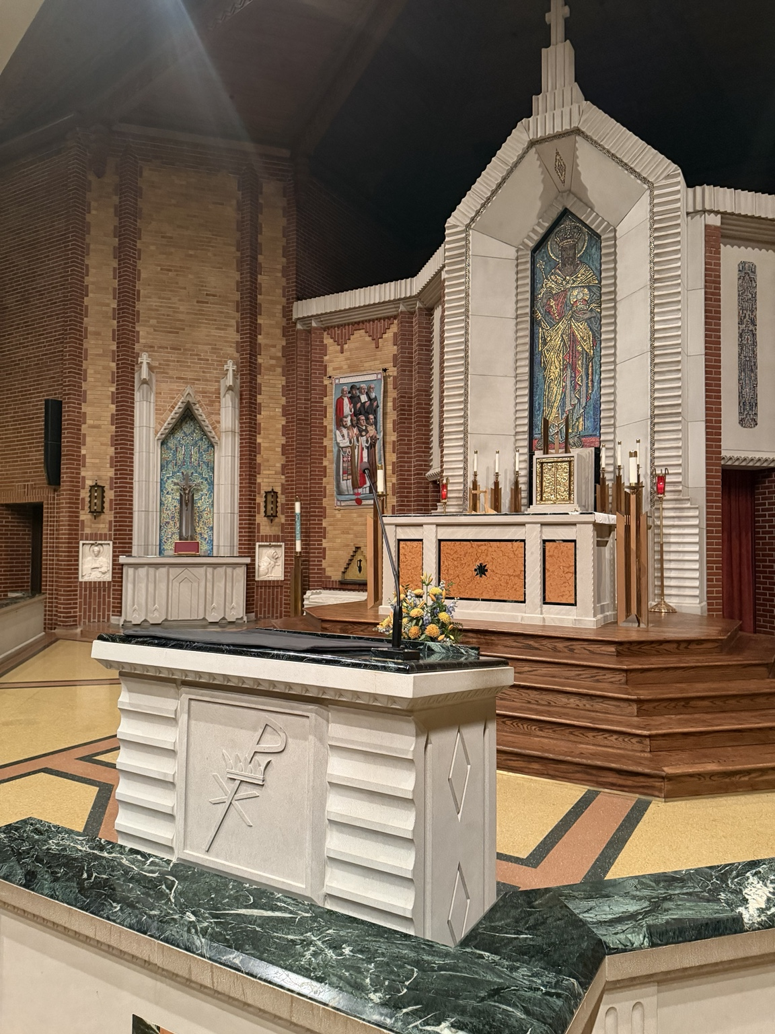
Figure 2. Angled view showing the carved parish emblem, patterned front, side diamonds, and dark green marble top. Supplied photograph IMG_8734(1).jpeg. Capture date not established.
The photograph documents visible features and their relationship to the rail and sanctuary. It does not establish stone specifications, concealed construction, or final dimensions. Specifications and proposed dimensions remain tied to the dated records that contain them.

Ed Grewe design sketch
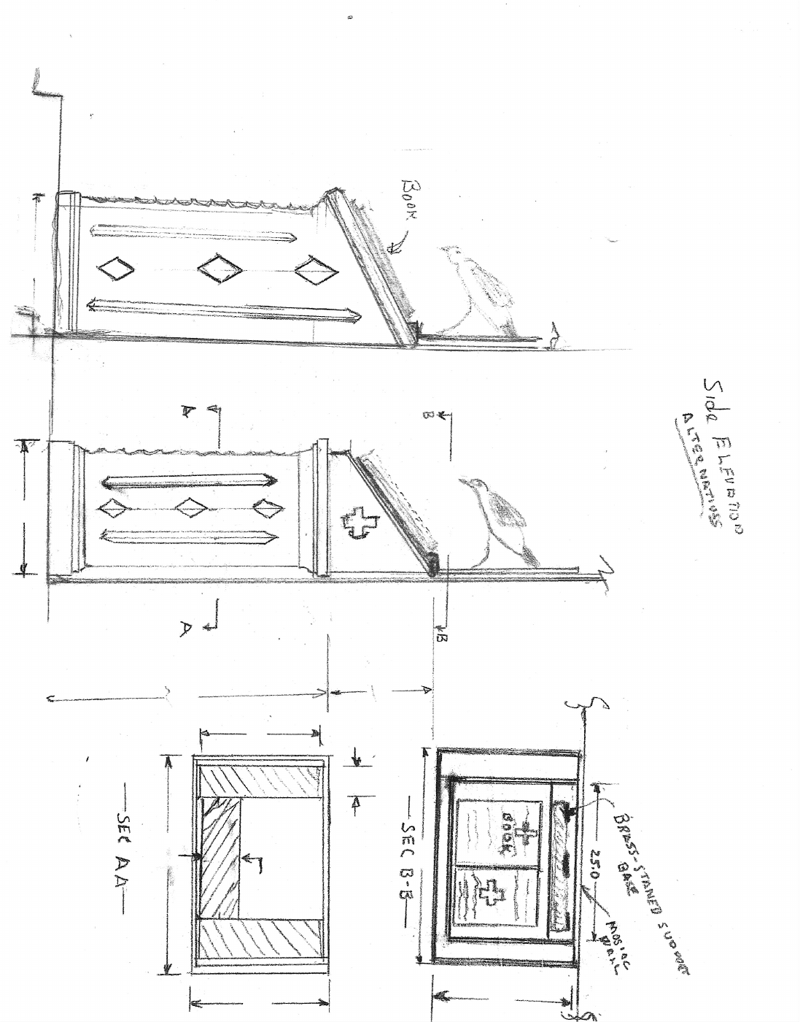
Figure 3. Undated sheet preserved as ambodraftbyedgrewe.pdf. The original one page PDF is included in the source bundle. [S6]
Two side elevation alternatives and section sketches show an earlier design stage. The source orientation is preserved.

Midwest Marble invoice
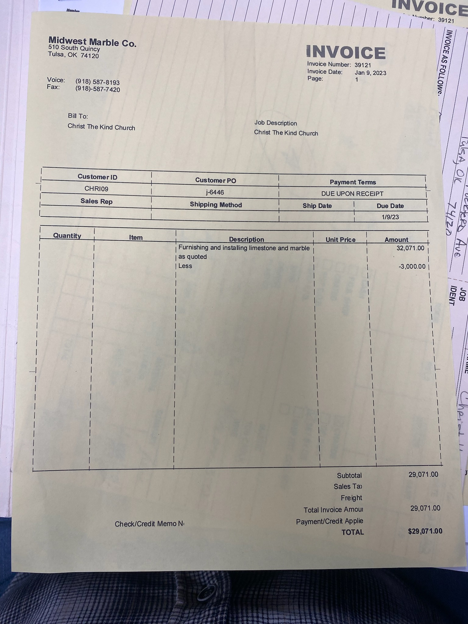
Figure 4. Invoice 39121 dated January 9, 2023. Photograph IMG_3787.jpg was sent to the parish inbox on March 8, 2023. [S4]
The invoice lists $32,071 for furnishing and installing limestone and marble, a $3,000 deduction, and a total of $29,071. No payment or credit applied is entered in the photographed field.

Source register
S1 Ambo Writeup/Communications Plan, October 11 to 19, 2022
Parish drafting and approval correspondence among Lacy Wulfers, Fr. Elkin González, and Chris Davenport.
Open source
S2 Ambo correspondence, undated archived document
Design objectives, material relationships, relic proposal, proportions, and accessibility concerns.
Open source
S3 Midwest Marble Co Invoice correspondence, March 8 to 24, 2023
Gift confirmation and accounting questions. March 8 message records $22,000 on February 17, 2022.
Open source
S4 Midwest Marble invoice 39121, January 9, 2023
Original attachment IMG_3787.jpg in March 8, 2023 message with no subject.
Open source
S5 6746 Christ the King Ambo, December 23 to 31, 2021
Diamond recess, green inlay, platform trim, and inquiry about chapel fabricator.
Open source
S6 ambodraftbyedgrewe.pdf, undated
One page sketch, retained unchanged as ed-grewe-draft.pdf in the source bundle.
Open source
S7 Next Steps for Ambo Project, January and February 2022
Meeting, materials, proposal coordination, and gift discussion.
Open source
S8 6746 AMBO, February 25 to March 6, 2022
Platform, relic surround, width, shelves, microphone, and repricing. Related Rev 2 and Lectern threads are preserved in the bundle.
Open source

Source register continued
S9 Christ the King Final Ambo Drawings, April 17 and 18, 2022
Seam, scallops, shelves, and microphone openings. Related April 29 cap change thread is included.
Open source
S10 last quote was on 5-12-22.pdf
May 12, 2022 quotation signed Steve Ferguson; $32,071. Included as may-12-quote.pdf.
Open source
S11 Christ the King Final quote, May 2022 and March 22, 2023
Forwarding, conditional approval, and Davenport’s later explanation of the logo change.
Open source
S12 Christ the King Final Drawings for Production.pdf
Seven sheets dated May 23, 2022, Ranier Devido Stone Co., with handwritten corrections. Included as production-drawings.pdf.
Open source
S13 New front panel and artwork, July 29 to August 2, 2022
Grewe’s direction, raised artwork, bevel, and crown contour. Three threads are preserved in the bundle.
Open source
S14 Ambo Final Notes, November 28, 2022
Includes November 1 and 2 messages on height discrepancy, replacement, and $3,000 deduction.
Open source
S15 AMBO Revision and Question, November 7 to 14, 2022
Proposed sidewall remake, rail clearance, stone color, and shelves.
Open source
S16 Midwest Marble Final Pricing.pdf
Eleven page file; page 1 dated March 21, 2022 quotes $23,802. The title does not supersede later pricing. Included as pricing.pdf.
Open source

Archive contents and remaining records
The companion source bundle preserves four original PDFs, the invoice photograph, the two supplied photographs, readable correspondence from sixteen selected threads, the archived Drive correspondence text, a source register, and a related file inventory. Source files are retained without alteration. A checksum manifest records the bytes included in this bundle.
The related file inventory contains 262 nonfolder records whose titles or archive paths include ambo. These are discovery records from the existing archive inventory, not 262 verified unique ambo sources. Copies, related altar and tabernacle records, and photographs remain distinguishable by their original paths and links. No duplicate originals have been deleted.
The earlier chat was used to locate the ongoing project context. Its narrative is not treated as primary evidence. The attached source records provide the basis for the historical account above. Hiding in Plain Sight is not used as evidence.

Records for follow up
Payment confirmation and final accounting reconciliation would establish how invoice 39121 was settled and whether a further gift covered the difference. The invoice’s $3,000 deduction agrees with the written offer, but its payment field is blank.
The final distributed parish announcement and a dated installation record would resolve the publication and installation dates more precisely. Shelf completion, final grout work, and verified installed dimensions would complete the construction closeout record.
The reviewed May 12 quote already totals $32,071, the same gross amount shown on the January invoice. Davenport’s later message describes the logo change as a difference between estimate and final. That explanation is preserved as correspondence; it is not converted into a separate charge without an itemized change order.
The source bundle includes text copies of selected email bodies, with quoted earlier messages retained. It is not a forensic mailbox export and does not embed every inline email image or every attachment. Drawings, photographs, and related records beyond the included originals remain accessible through the linked Drive inventory.
Open the ambo object archive

